Coronaviruses – What They Are and How They Can Make You Sick

1. What do you know about COVID-19 and the novel coronavirus that causes COVID-19? What questions do you have?

Introduction to Coronaviruses

There are many different types of coronavirus that infect many different types of animals. In 2019 a novel coronavirus began to cause illness and deaths in humans. By March 1, 2022, this novel coronavirus had caused over 6 million deaths worldwide and over 0.9 million deaths in the US.

To learn about this novel coronavirus:

• view “SARS-CoV-2 Infection” (https://media.hhmi.org/biointeractive/click/covid/infection.html)

• read “How coronaviruses replicate inside you” (https://www.latimes.com/projects/how-coronavirus-invade-cells-replicates/).

2a. Fill in the blanks in this flowchart to describe how new coronaviruses are made.
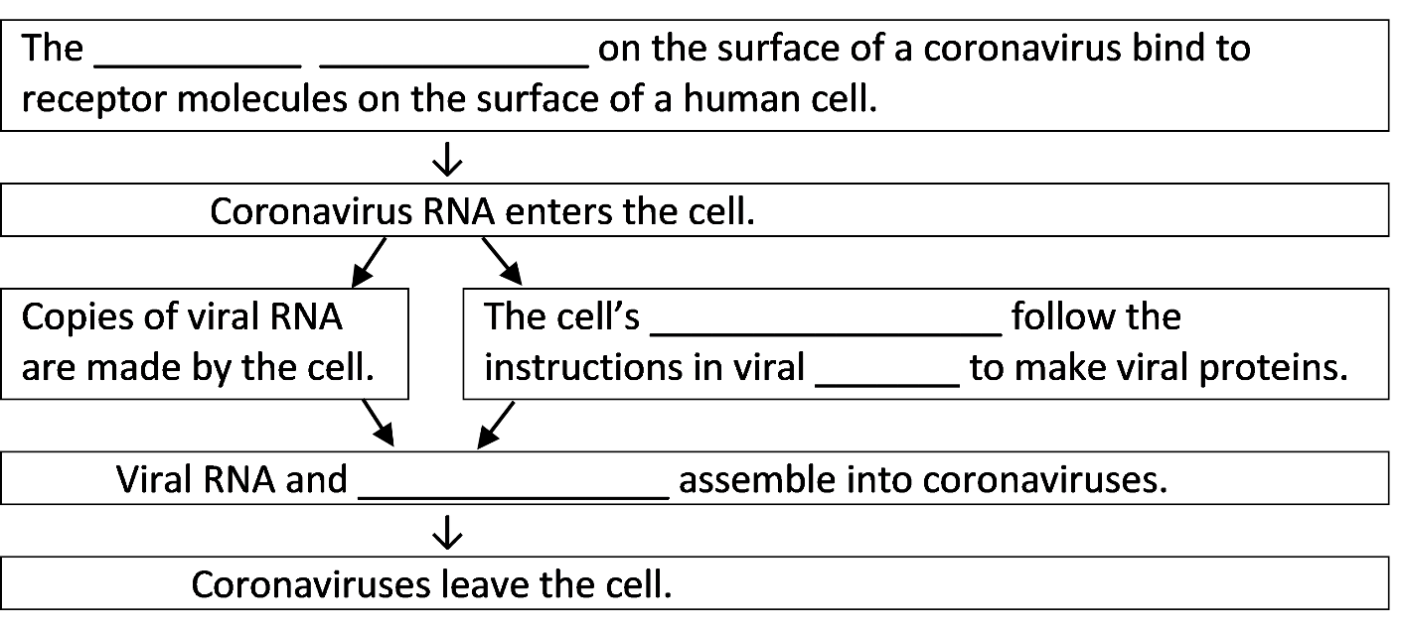
2b. Explain why a coronavirus can’t reproduce on its own and instead needs to use our cells to make more coronaviruses.

2c. How big is a coronavirus compared to your cells?

How can something so tiny make a person feel sick?

The coronavirus infects cells in the respiratory system. Infected cells usually die after producing hundreds of coronaviruses. These coronaviruses infect other cells, which also die. This causes damage to the respiratory system.

When the white blood cells of the immune system detect a coronavirus infection, they try to get rid of the coronaviruses. White blood cells attack and destroy both the coronaviruses and any infected cells.

3. Why is it useful for white blood cells to attack cells that have been infected with coronavirus?

In response to an infection, white blood cells release chemical signals that stimulate multiple responses. For example, gaps open between the cells in the walls of capillaries (the smallest
blood vessels).  4a. Circle the white blood cell that is squeezing through a gap in the capillary wall.  4b. Explain how this response helps to fight a coronavirus infection. | 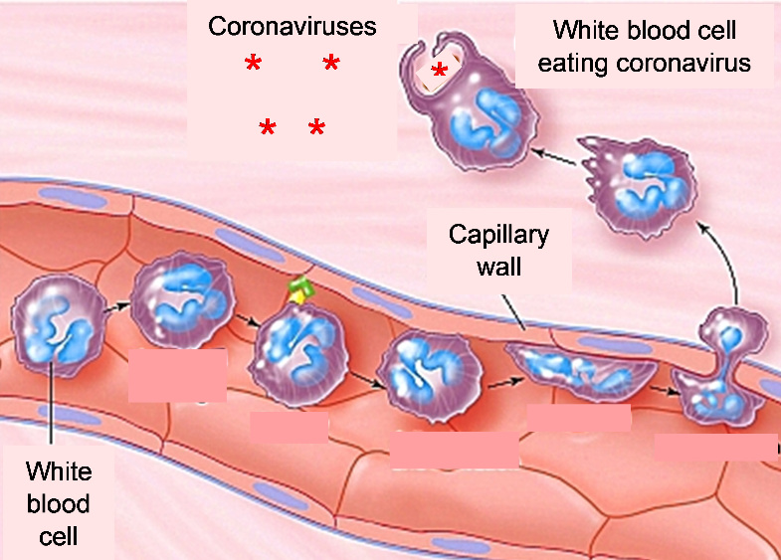

Some of the chemical signals from white blood cells cause fever and fatigue. Fever and fatigue contribute to feeling sick when a person has a coronavirus infection, but they also help to fight the coronavirus infection. The increase in body temperature improves immune system function. Because the person feels tired, he or she rests more, so more energy is available for fighting the coronavirus.

5. Draw a flowchart to show how white blood cell responses can get rid of a coronavirus infection, even without any medical treatment. A complete answer will include chemical signals, capillaries, fever and fatigue.

6. Why do many people with a coronavirus infection feel sick?

By Dr. Ingrid Waldron, Dept Biology, Univ Pennsylvania, © 2022; this Student Handout, a longer version with more information about how a coronavirus infection causes illness, and Teacher Notes (with instructional suggestions and background biology) are available at https://serendipstudio.org/exchange/bioactivities/coronavirusintro.

